**Guia CardView**

1. Crear un proyecto base
2. Agregar la librería de diseño para soportar CardView

apply **plugin**: **'com.android.application'**

android {

compileSdkVersion 25

buildToolsVersion **"26.0.1"**

defaultConfig {

applicationId **"ucb.bo.edu.cardviewexample"**

minSdkVersion 21

targetSdkVersion 25

versionCode 1

versionName **"1.0"**

testInstrumentationRunner **"android.support.test.runner.AndroidJUnitRunner"**

}

buildTypes {

release {

minifyEnabled **false**

proguardFiles getDefaultProguardFile(**'proguard-android.txt'**), **'proguard-rules.pro'**

}

}

}

dependencies {

compile fileTree(**dir**: **'libs'**, **include**: [**'*.jar'**])

androidTestCompile(**'com.android.support.test.espresso:espresso-core:2.2.2'**, {

exclude **group**: **'com.android.support'**, **module**: **'support-annotations'**

})

compile **'com.android.support.constraint:constraint-layout:1.0.2'**

testCompile **'junit:junit:4.12'**

compile **'com.android.support:cardview-v7:25.3.1'**

}

3. Modificar el archivo activity_main.xml

*<?***xml version="1.0" encoding="utf-8"***?>*

<**LinearLayout xmlns:android="http://schemas.android.com/apk/res/android"**

**xmlns:app="http://schemas.android.com/apk/res-auto"**

**xmlns:tools="http://schemas.android.com/tools"**

**android:layout_width="match_parent"**

**android:layout_height="match_parent"**

**android:layout_margin="5dp"**

**android:orientation="vertical"**

**tools:context="ucb.bo.edu.cardviewexample.MainActivity"**>

<**android.support.v7.widget.CardView**

**android:layout_width="match_parent"**

**android:layout_height="wrap_content"**

**android:padding="5dp"**>

<**TextView**

**android:id="@+id/textView"**

**android:layout_width="match_parent"**

**android:layout_height="wrap_content"**

**android:layout_margin="5dp"**

**android:padding="10dp"**

**android:text="TextView"** />

</**android.support.v7.widget.CardView**>

</**LinearLayout**>

4. Realizar los siguiente ejemplos utilizando CardView

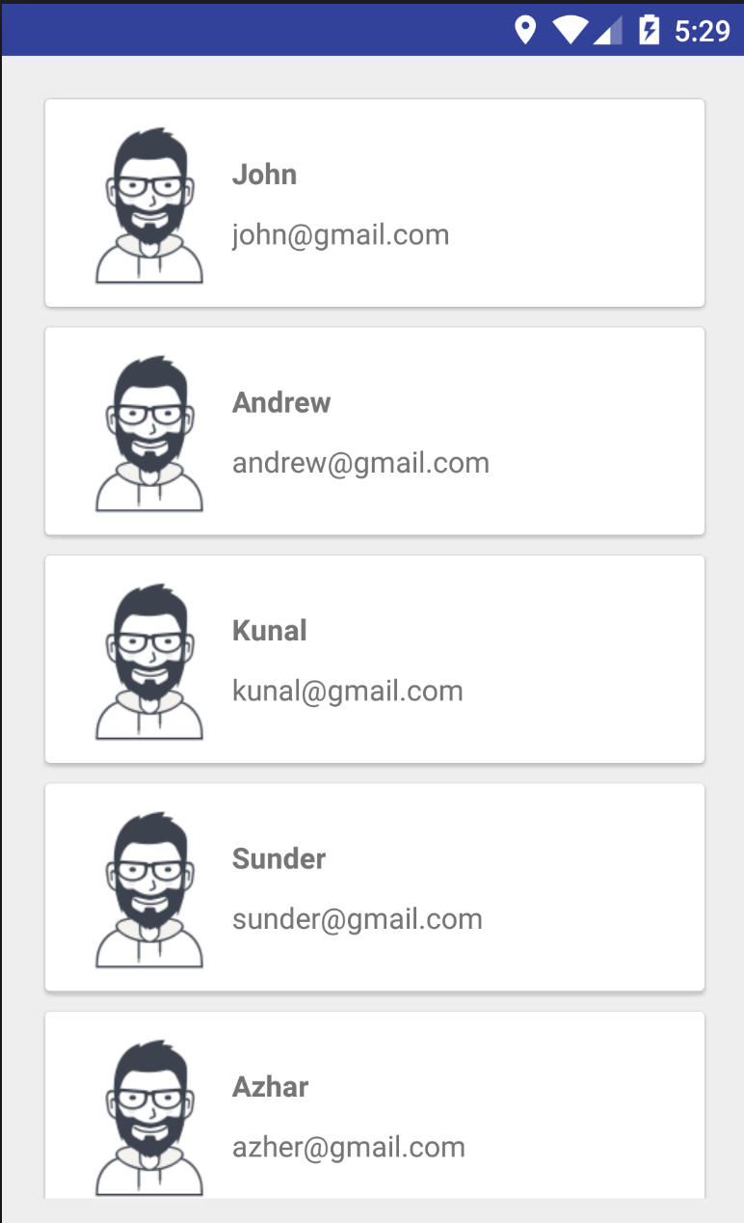

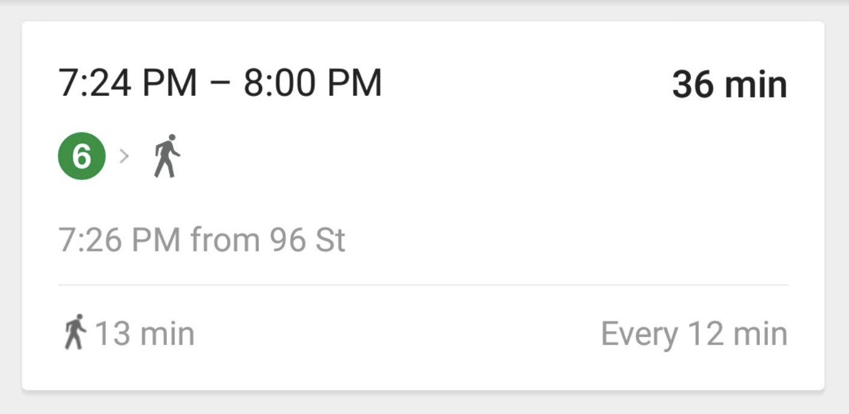

<https://github.com/calyr/CardViewExample>